1. Write a Python Program to Find the Factorial of a Number?

Ans: 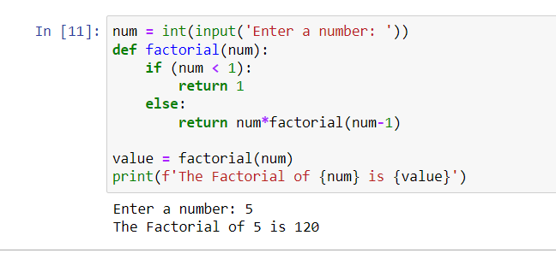

1. Write a Python Program to Display the multiplication Table?

Ans: 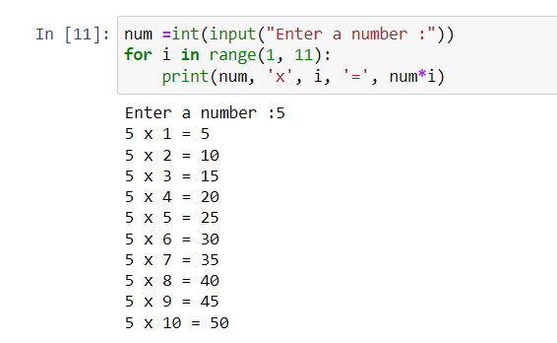

1. Write a Python Program to Print the Fibonacci sequence?

Ans: 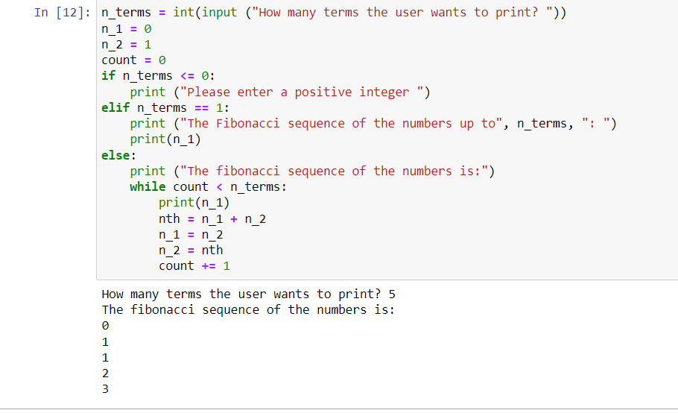

1. Write a Python Program to Check Armstrong Number?

Ans: 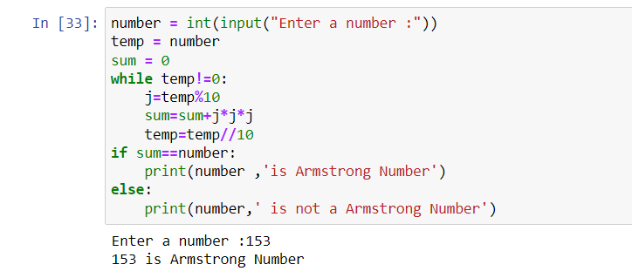

1. Write a Python Program to Find Armstrong Number in an Interval.

Ans: 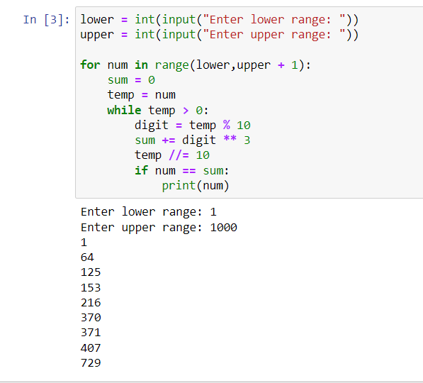

1. Write a Python Program to Find the Sum of Natural Numbers?

Ans: 